**SCHOOL OF COMPUTER SCIENCE**

**UNIVERSITY OF PETROLEUM AND ENERGY STUDIES**

**DEHRADUN, UTTARAKHAND**



**IT DATA SECURITY LAB**

**LABORATORY FILE**

**(2024-2025)**

**For**

**Vth Semester**

**Submitted To: Submitted By:**

Prof. Abhishek Yadav Mr. Akshat Negi

Assistant Professor S.S. 500106533(SAP ID)

[Vth Semester] R2142220414(Roll No.)

School of Computer Sciences B.Tech. CSF (Batch-1)

**LAB EXPERIMENT – 8**

**Elasticsearch and Kibana for Data Analysis**

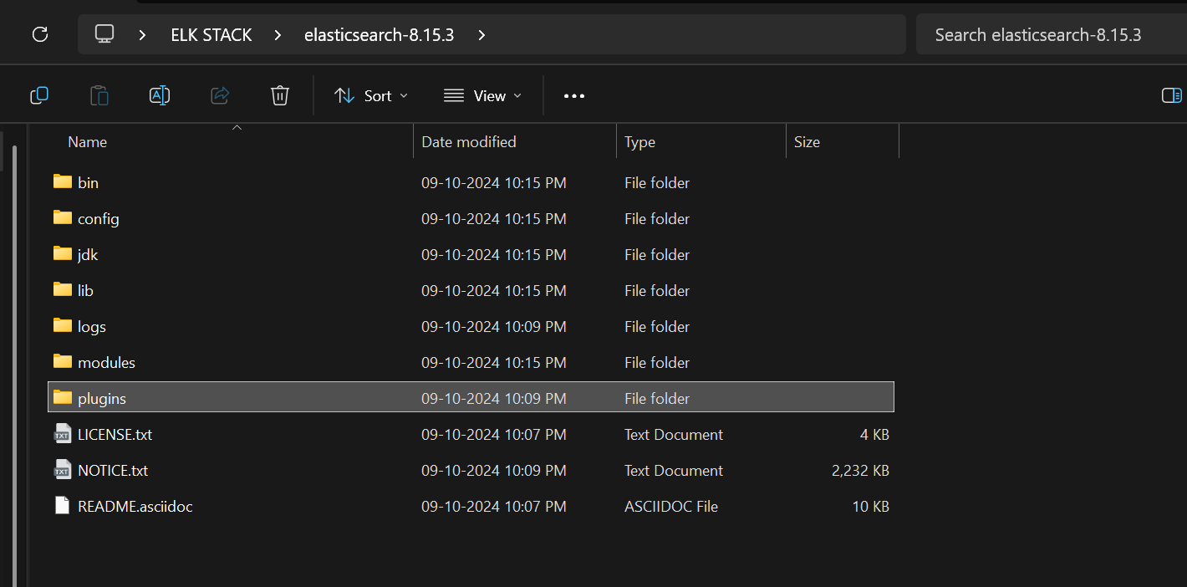

Add this line in elasticsearch.yml file present in config folder.

action.auto_create_index: .monitoring*,.watches,.triggered_watches,.watcher-history*,.ml*

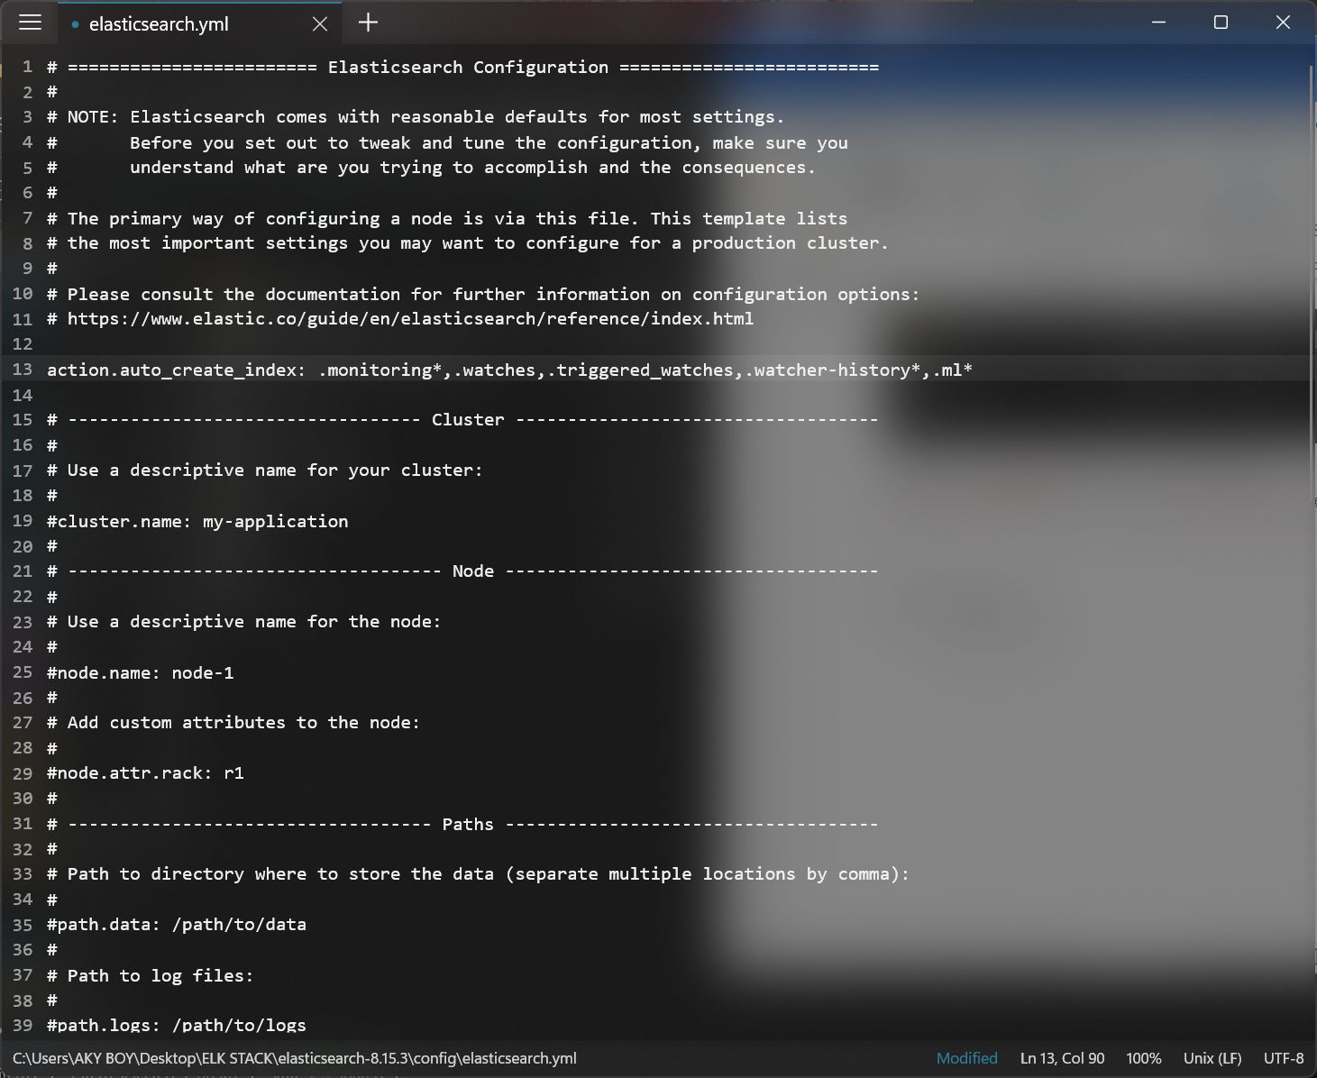

Start the Elastic search

cd bin

elasticsearch.bat

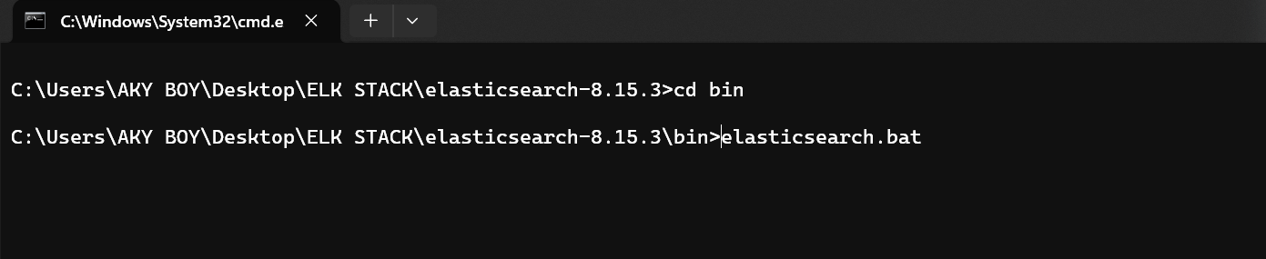

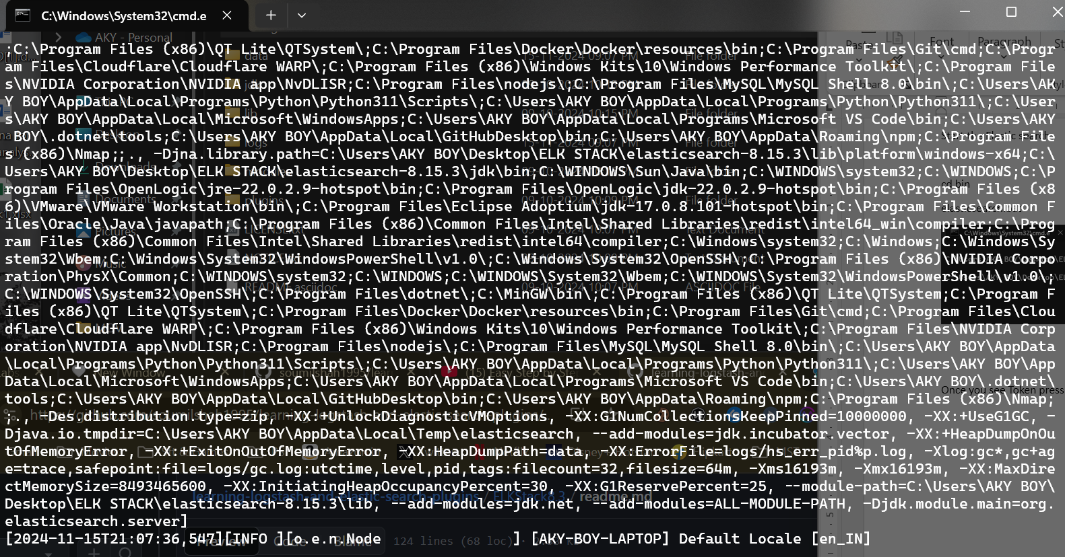

Once you see Token press CTR + C and stop it and copy Paste TOKEN

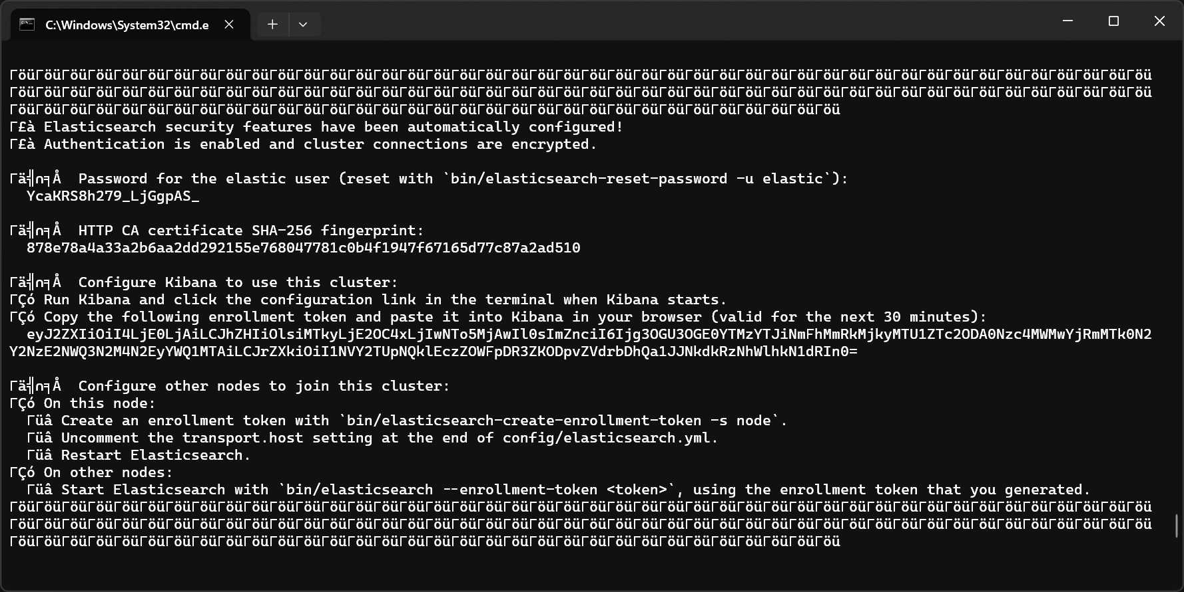

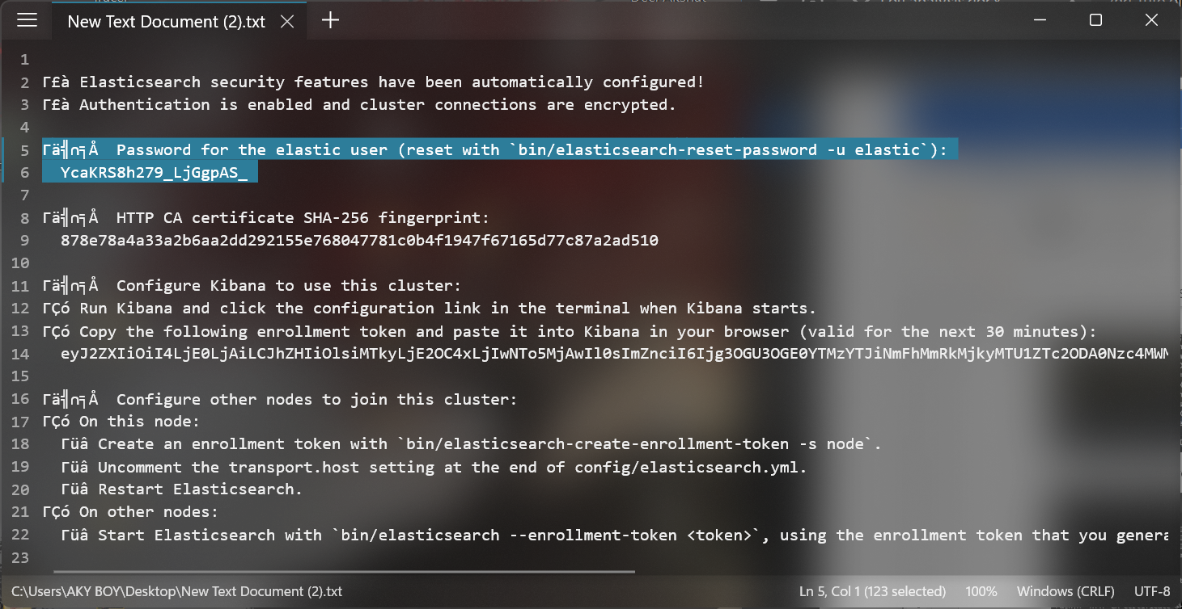

Open elasticsearc.yml file again

***********

SET this to false

enabled: true

*************

xpack.security.http.ssl:

enabled: false

keystore.path: certs/http.p12

xpack.security.transport.ssl:

enabled: false

verification_mode: certificate

keystore.path: certs/transport.p12

truststore.path: certs/transport.p12

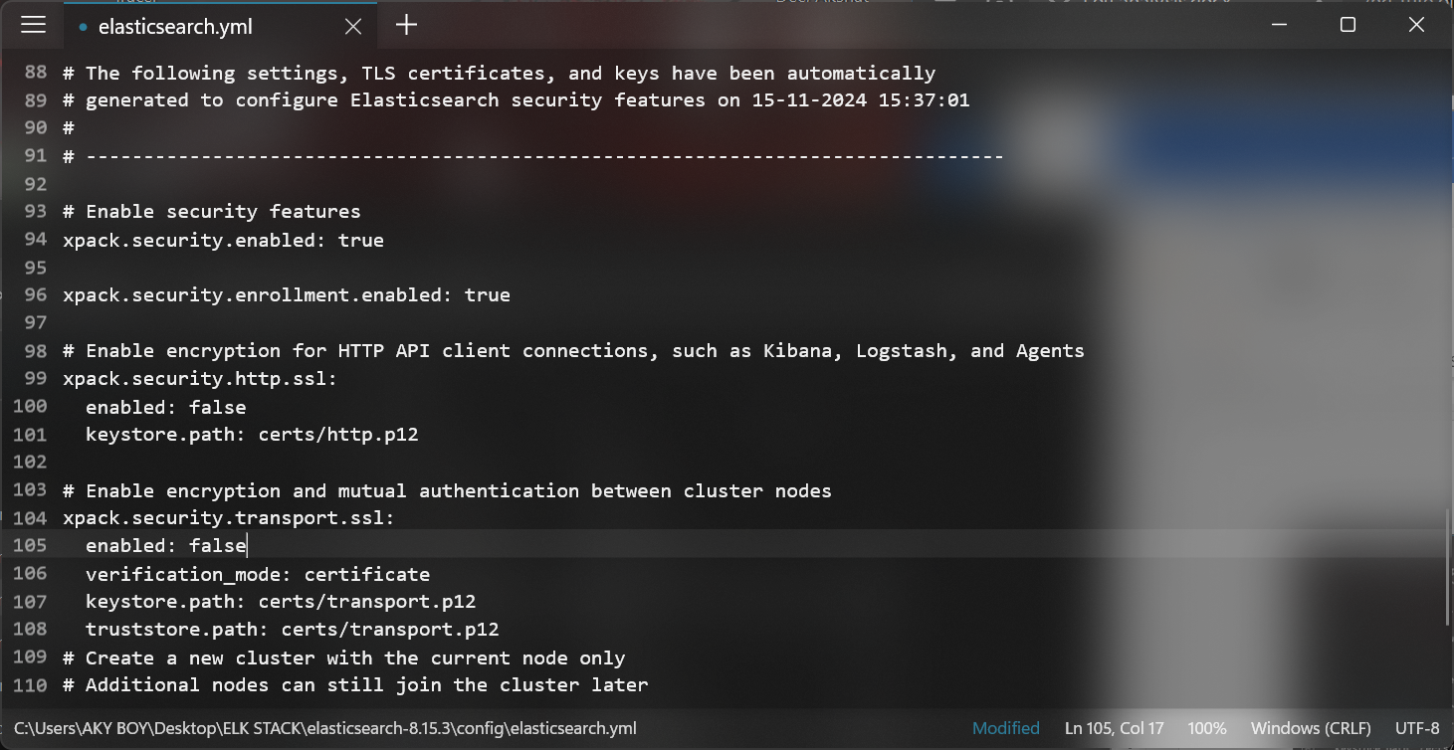

Start elastic search

elasticsearch.bat

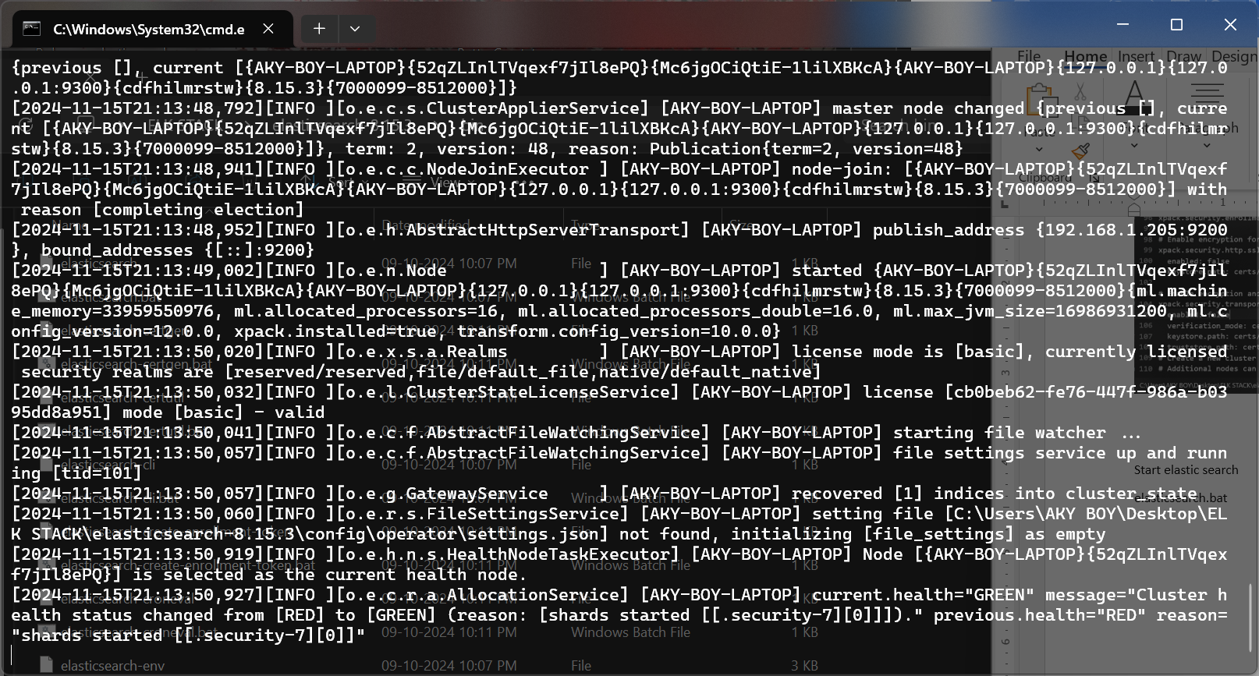

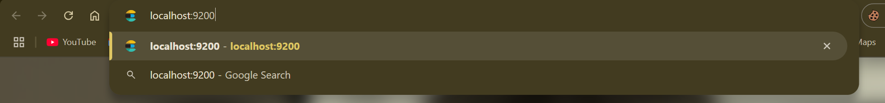

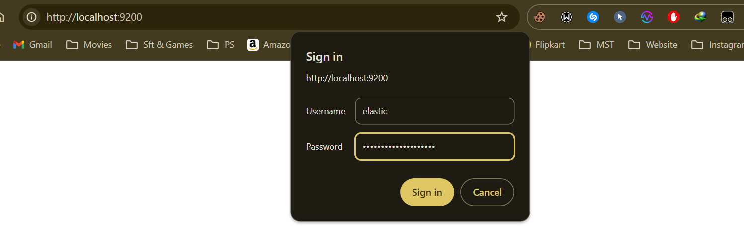

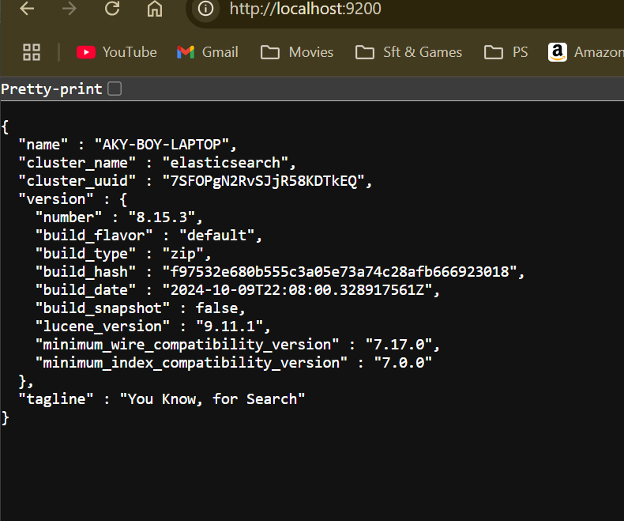

Elastic Search Works Perfectly

GO TO BIN directory and OPEN CMD

elasticsearch-reset-password -u elastic

elasticsearch-reset-password -u kibana_system

NOTE THE PASS ON NOTEPAD

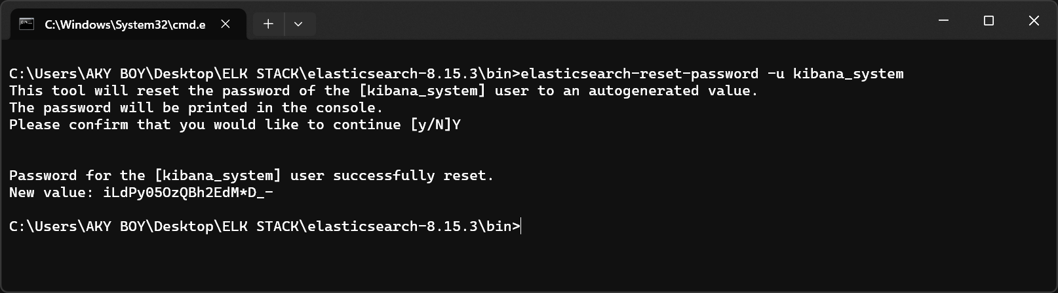

Kibana

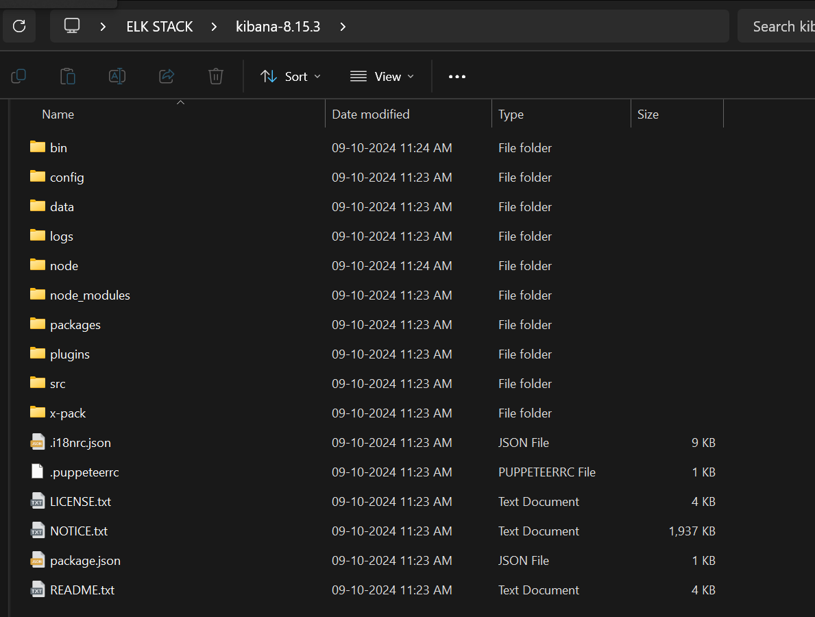

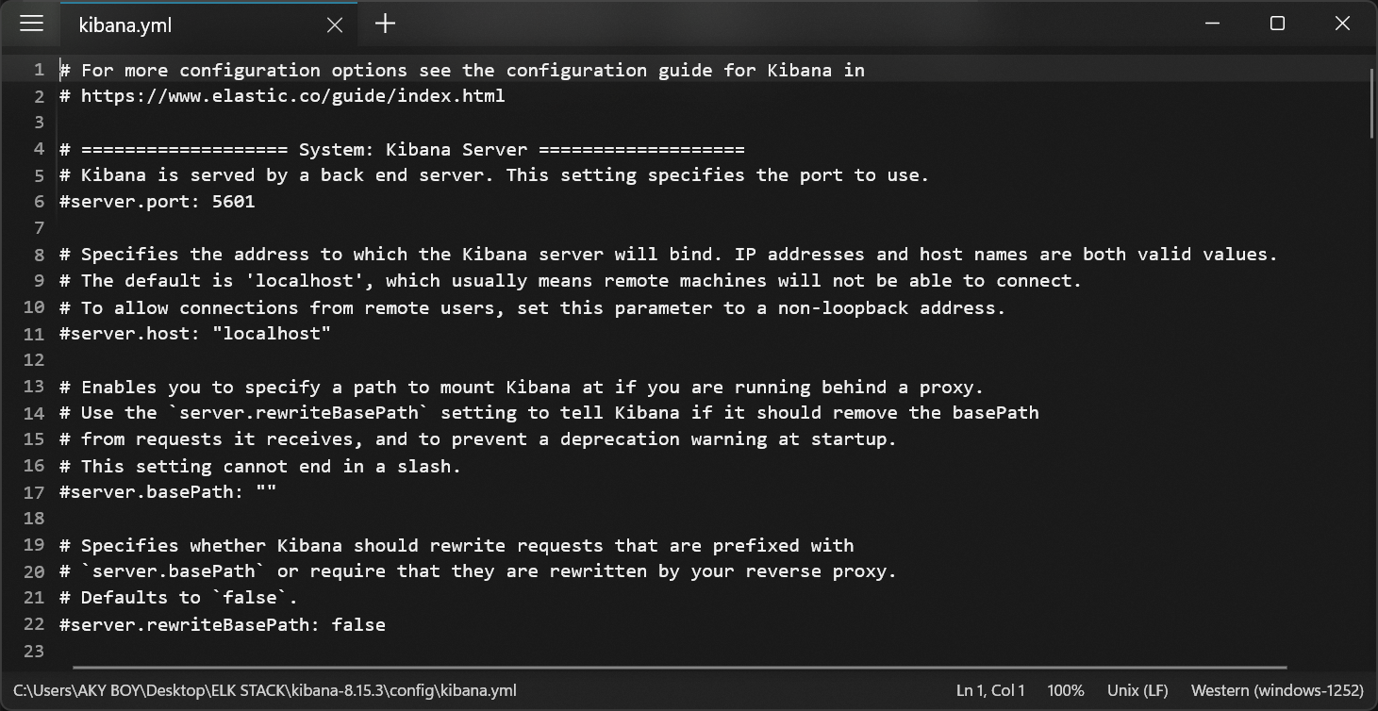

#server.port: 5601

#server.host: "localhost"

#elasticsearch.hosts: ["http://localhost:9200"]

#elasticsearch.username: "kibana_system"

#elasticsearch.password: "pass"

Replace it with elasticsearch.password: "iLdPy05OzQBh2EdM*D_-"

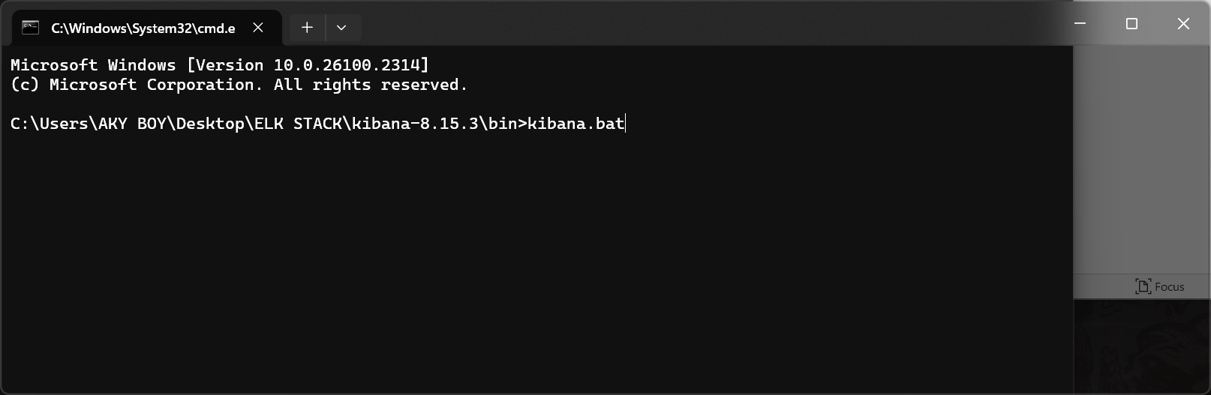

Find the redirecting localhost 9200 url in the cmd to redirect u to the kibana system.

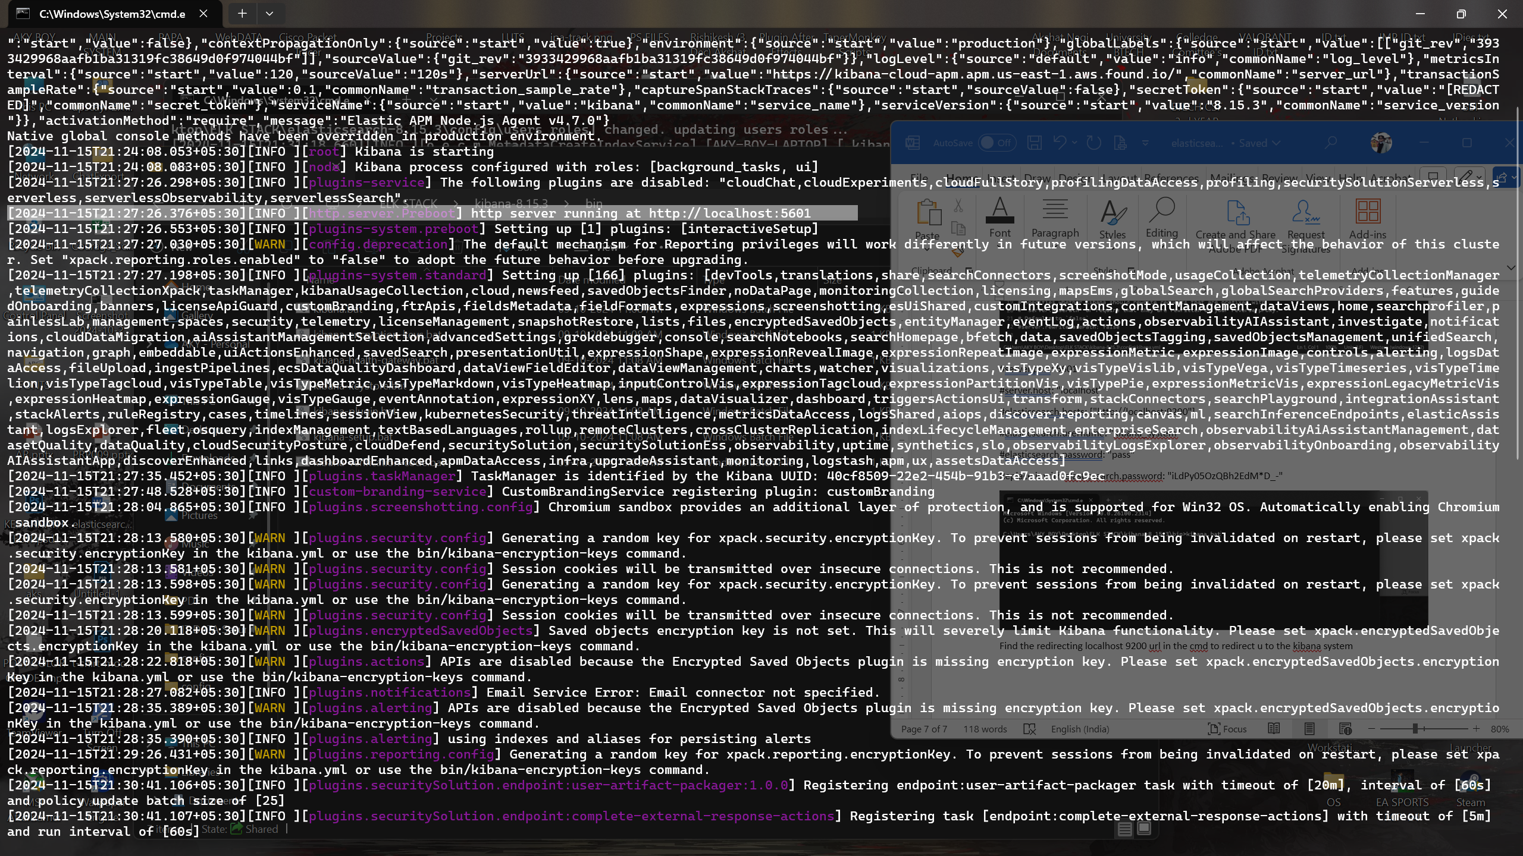

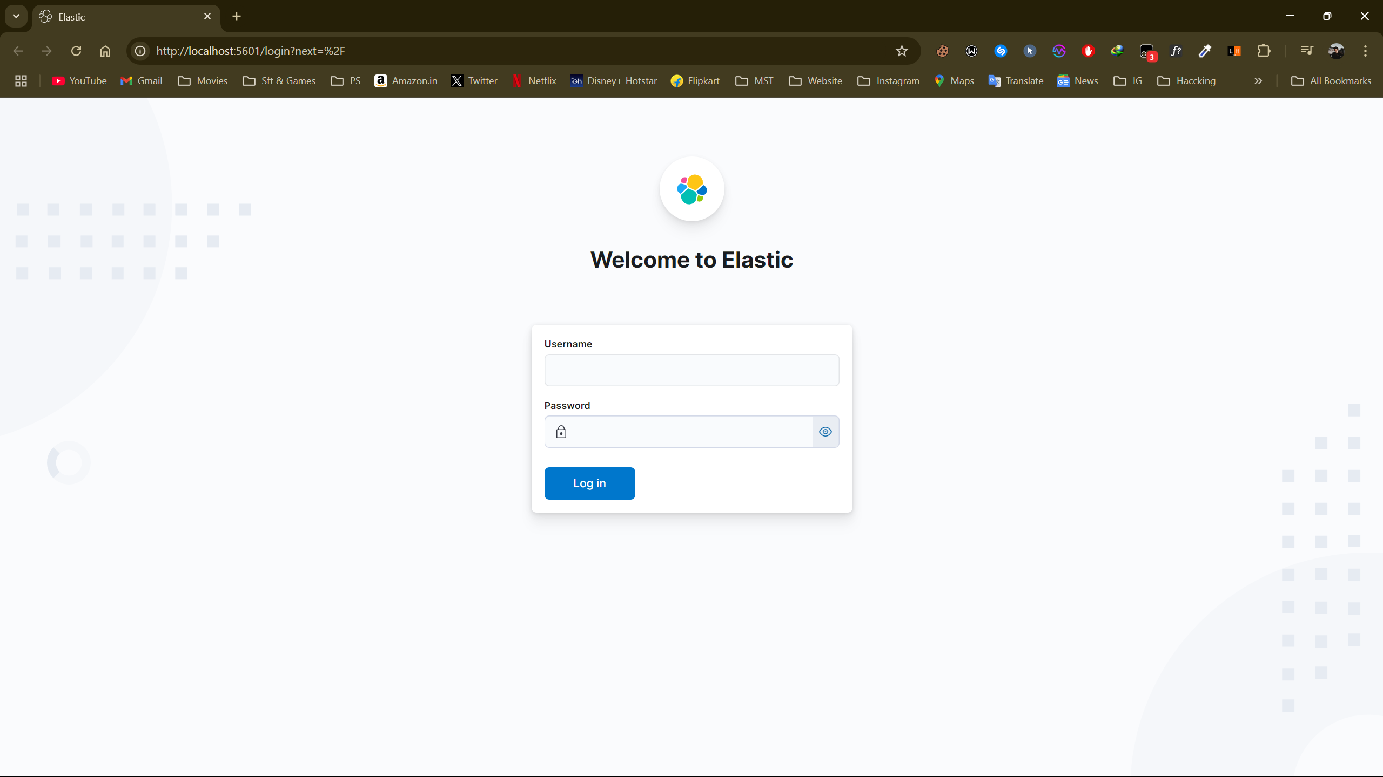

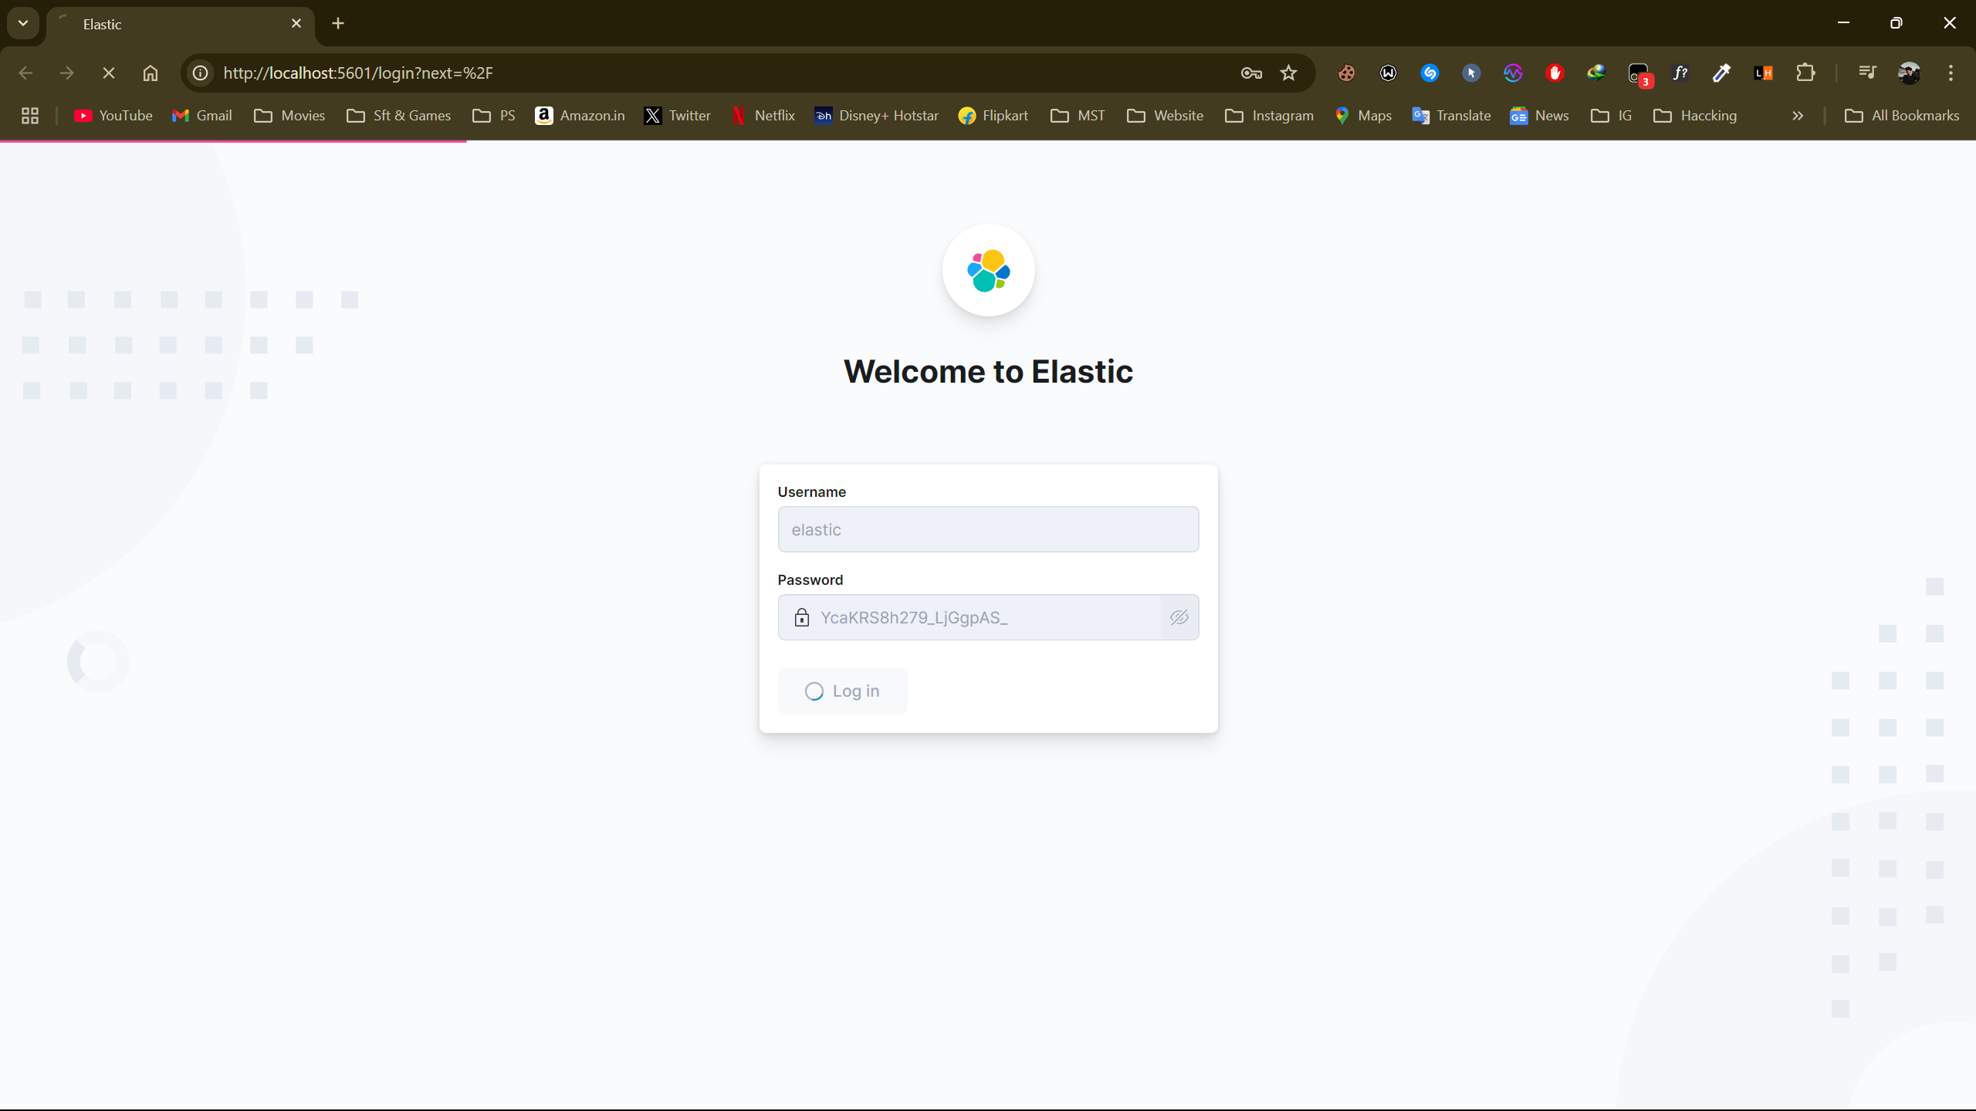

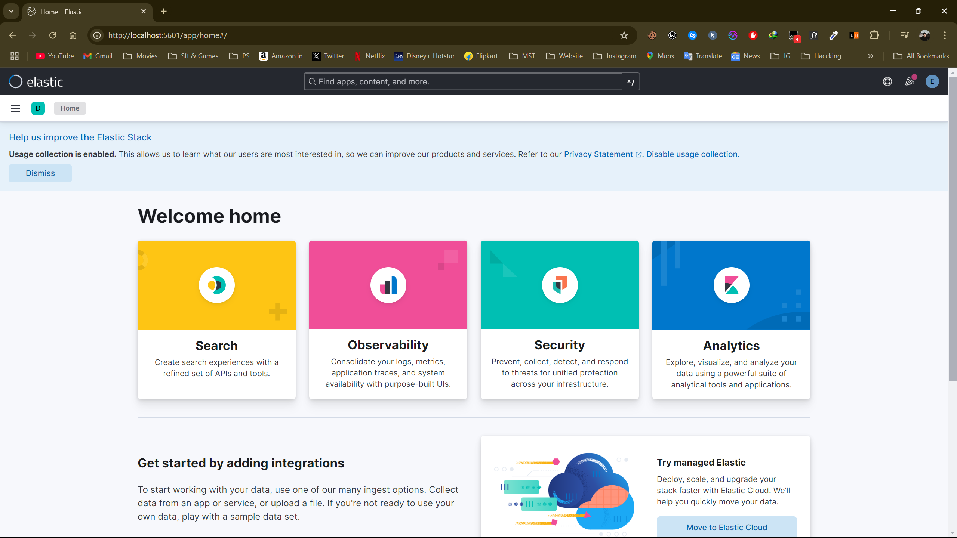

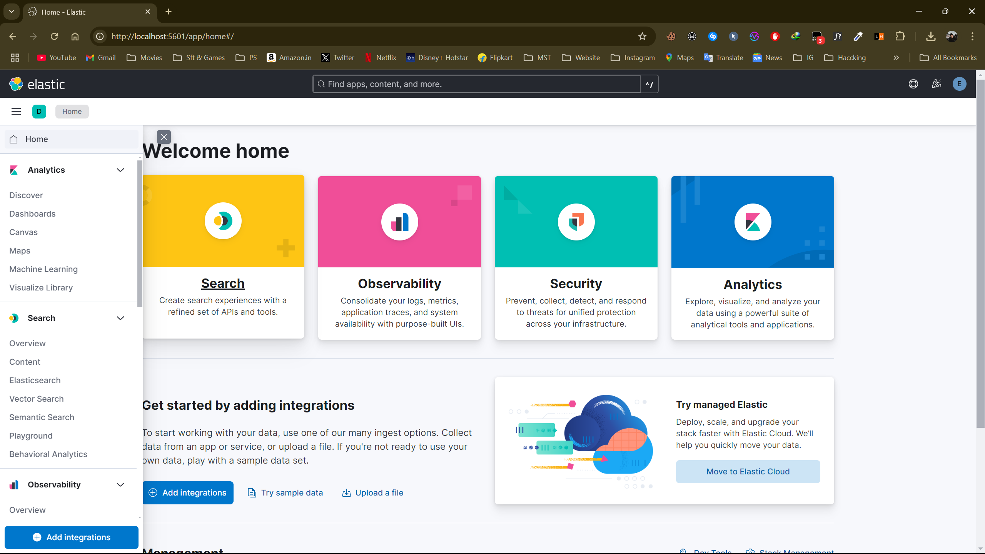

**Creating Visualizations in Kibana**

**Types of Visualizations**

Kibana supports a variety of visualization types:

* **Bar Charts**: Display trends or comparisons.
* **Line Charts**: Show continuous data over time.
* **Pie Charts**: Represent proportions or percentages.
* **Maps**: Visualize geospatial data.
* **Tables**: Display raw data in tabular format.
* **Metric Visualizations**: Highlight key metrics or single values.

**Steps to Create a Visualization**

1. **Navigate to Visualizations**:
   * Go to *Visualize Library* → *Create Visualization*.
2. **Choose a Visualization Type**:
   * Select the type that best fits your data and analysis goals.
3. **Select Data Source**:
   * Choose the index pattern or saved search to use as the data source.
4. **Configure Visualization Options**:
   * **Metrics**: Define the metrics (e.g., Average, Count, Sum) for aggregation.
   * **Buckets**: Split data into groups or categories.
   * Customize labels, colors, and other settings.
5. **Preview and Save**:
   * Review the visualization.
   * Click *Save* and name your visualization.

**Example: Create a Bar Chart**

1. Go to *Visualize Library* → *Create Visualization* → *Bar Chart*.
2. Select your index pattern.
3. In the **Metrics** section, choose Count as the aggregation type.
4. In the **Buckets** section, choose X-Axis, and then select a field to group by (e.g., category).
5. Adjust the chart's appearance and labels.
6. Save the visualization.

Dos Attack Data Set

* Installation already done in Last Tutorial.
* I performed a DoS attack on a Kali system and saved the DoS
* attack data using wireshark.
* Data set (CSV, JSON, pcap, pcapng)
* Then add this dataset to Kibana. (At home page there is option

upload a file)

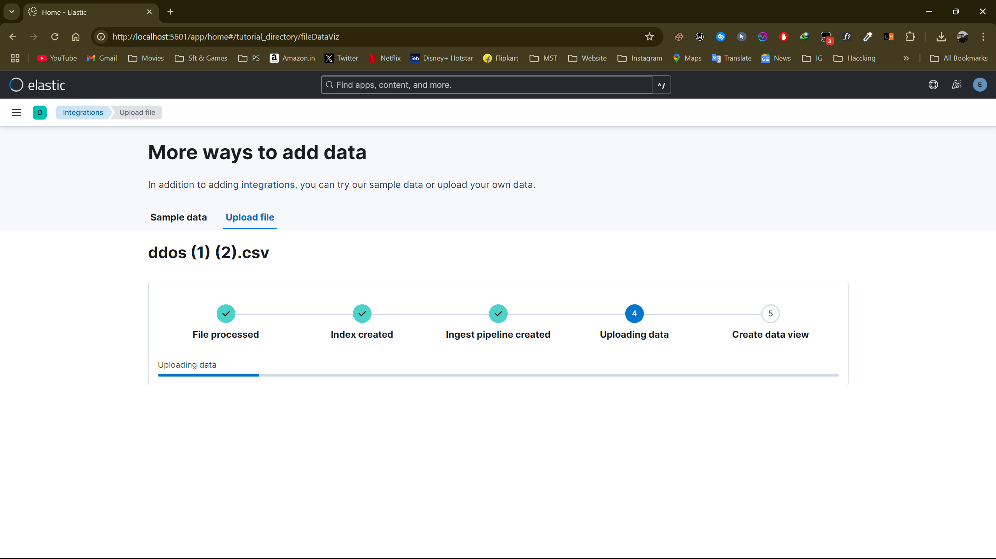

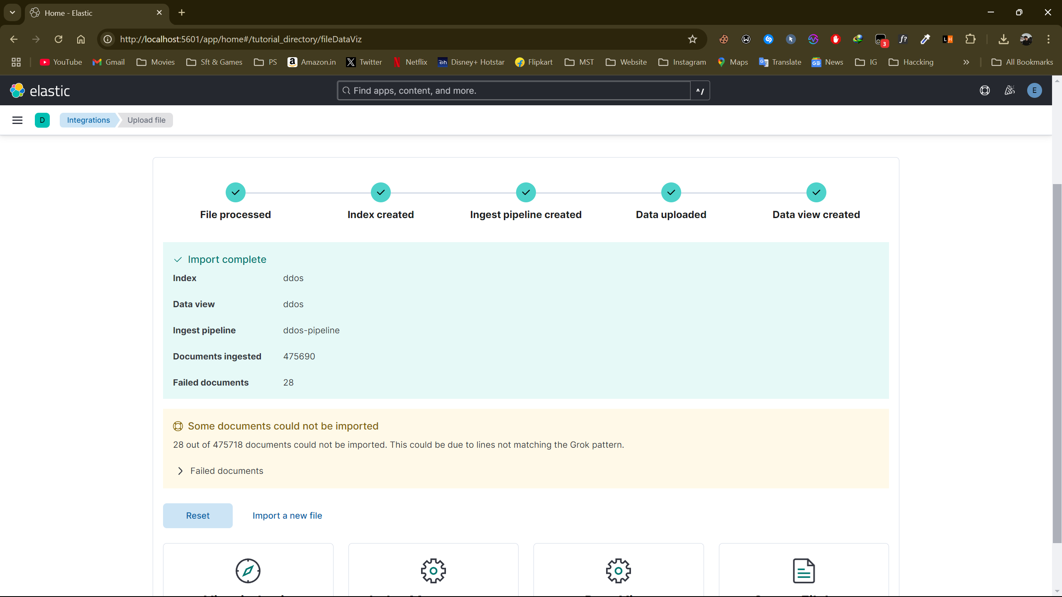

Go to the dashboard, then create a new visualization and

use the dataset that was uploaded. Select the field you

want to visualize.

